Java Object-Oriented Programming Experimental Report
NO: Experiment 2 Experiment name：Data and Expressions
Student ID | 1607052230 | Name | 邱冠霖 | Class |  | 16软件工程
Location | 实1-314 | Teacher | 唐朝辉 | Time |  | 2018-03-23
1.Experimental purposes and requirements
1.1 Print and println, String literals, String concatenation, Escape sequences
1.2 Variables, Constants, Assignment, Integers and Floating point, Arithmetic Expressions, Operator Precedence, Input using the Scanner class
1.3 HTML, Applets, Graphics, Colors
2.Experimental equipment (environment) and requirements
2.1 Eclipse
2.2 Window XP
3.Lab Exercises(Please see Lab Manual)
3.1 Names and Places(Choose to do)
3.2 Table of Student Grades(Choose to do)
3.3 Two Meanings of Plus
3.4 Pre-lab Exercises
3.5 Area and Circumference of a Circle
3.6 Painting a Room(Choose to do)
3.7 Ideal Weight
3.8 Lab Grades(Choose to do)
3.9 Base Conversion(Choose to do)
3.10 Introduction to HTML(Choose to do)
3.11 Drawing Shapes
3.12 The Java Coordinate System(Choose to do)
3.13 Drawing a Face(Choose to do)
3.14 Creating a Pie Chart(Choose to do)
3.15 Colors in Java(Choose to do)
4.Experimental results and data processing

5.Analysis and discussion
没有遇到什么问题，源代码都放在github上，欢迎讨论
https://github.com/kong1414/JavaLesson.git
6.Teacher Reviews  Signature：  Date： |  |  |  |  | Score:

Experimental Report List
1 Names and Places
1) Source code list
package Chapter02;
/**
* @Description:
* @Author: QiuGuanLin
* @Date: 2018/3/23 10:34
*/
public class Names {
// -----------------------
// main prints the list
// -----------------------
public static void main(String[] args) {
System.out.println();
System.out.println("\tName\t\tHometown");
System.out.println("\t====\t\t========");
System.out.println("\t邱冠霖\t\t厦门");
System.out.println("\t张 成\t\t厦门");
System.out.println();
System.out.println("\t姓名 \t\t专业");
System.out.println("\t====\t\t========");
System.out.println("\t邱冠霖\t\t软件工程");
System.out.println("\t张成 \t\t软件工程");
}
}

2) Results data processing
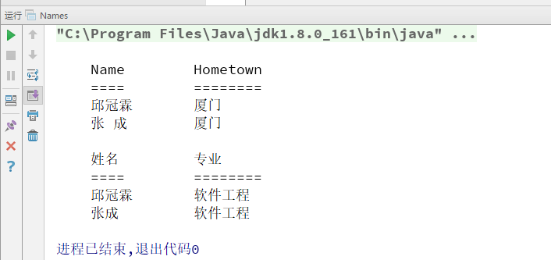

3) Answer questions

4)Error Analysis and Discussion

2 Table of Student Grade s
1) Source code list
package Chapter02;
/**
* @Description:
* @Author: QiuGuanLin
* @Date: 2018/3/23 10:41
*/
public class Grades {
public static void main(String arg[]) {
System.out.println("///////////////////"
+ "\\\\\\\\\\\\\\\\\\\\\\\\\\\\\\\\\\\\\\ ");
System.out.println("== Student Points ==");
System.out.println("\\\\\\\\\\\\\\\\\\\\\\\\\\\\\\\\\\\\\\"
+ "///////////////////");
System.out.println("Name\t\tLab\tBonus\tTotal");
System.out.println("----\t\t---\t-----\t-----");
System.out.println("Joe\t\t43\t7\t50");
System.out.println("William\t\t50\t8\t8");
System.out.println("Mary Sue\t39\t10\t49");
System.out.println("邱冠霖\t\t100\t100\t200");
System.out.println("张成 \t\t43\t77\t130");
}
}

2) Results data processing
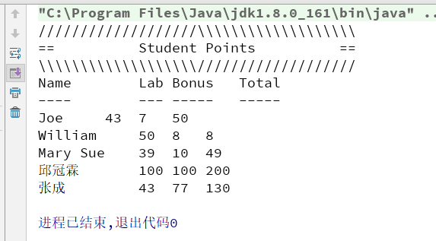

3) Answer questions

4)Error Analysis and Discussion

3 Two Meanings of Plus
1) Source code list
package Chapter02;
// ****************************************************
// PlusTest.java
//
// Demonstrate the different behaviors of the + operator
// **************************************************
/**
* @Description:
* @Author: QiuGuanLin
* @Date: 2018/3/23 10:45
*/
public class PlusTest {
// -------------------------------------------------
// main prints some expressions using the + operator
// -------------------------------------------------
public static void main(String[] args) {
//如果 + 一边是字符串，另一边将转换为字符串再连接
System.out.println("This is a long string that is the " +
"concatenation of two shorter strings.");
//如果 + 一边是字符串，另一边将转换为字符串再连接
System.out.println("The first computer was invented about" + 55 +
"years ago.");
//如果+一边是字符串，另一边将转换为字符串再连接
System.out.println("8 plus 5 is " + 8 + 5);
//如果有圆括号，圆括号先算，没有括号从左到右计算
System.out.println("8 plus 5 is " + (8 + 5));
//如果+运算符两边都是数字，则表示加法运算
System.out.println(8 + 5 + " equals 8 plus 5.");
System.out.println("Ten robins plus " + 13 + " canaries is " + 23 + " birds.");
}
}

2) Results data processing
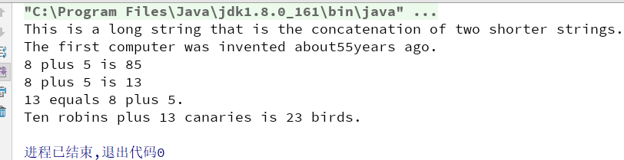

3) Answer questions

4)Error Analysis and Discussion

4 Prelab Exercises
1) Source code list
package Chapter02;
import java.util.Scanner;
/**
* @Description:
* @Author: QiuGuanLin
* @Date: 2018/3/23 10:51
*/
public class Average {
public static void main(String[] args) {
int val1, val2, val3;
double average;
Scanner scan = new Scanner(System.in);
// get three values from user
System.out.println("Please enter three integers and " +
"I will compute their average");
val1 = scan.nextInt();
val2 = scan.nextInt();
val3 = scan.nextInt();
//compute the average
average = (val1 + val2 + val3) / 3;
//print the average
System.out.println(average);
}
}

2) Results data processing
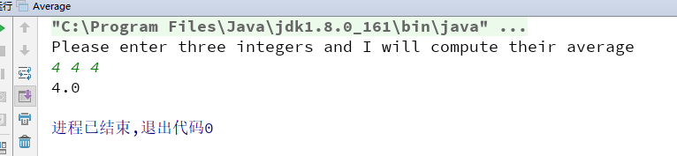

3) Answer questions
改错：
1、import 前面不加 # 号
2、注释用双 // 而不是用单 /
3、每条语句后面要加 ；号
4、name实String类型，不是int类型
5、print的括号里缺少后置”号
6、numSquared变量未定义
7、println里缺少连接符 + 号
8、主方法{}不匹配

4)Error Analysis and Discussion

5 Area and Circumference of a Circle
1) Source code list
1.
package Chapter02;
/**
* @Description:
* @Author: QiuGuanLin
* @Date: 2018/3/23 10:57
*/
public class Circle {
public static void main(String[] args) {
final double PI = 3.14159;
int radius = 10;
double area = PI * radius * radius;
double circumference = 2 * PI * radius;
System.out.println("The area of a circle with radius " + radius +
" is " + area);
System.out.println("The circumference of a circle with radius " + radius +
" is " + circumference);
radius = 20;
area = PI * radius * radius;
circumference = 2 * PI * radius;
System.out.println("The area of a circle with radius " + radius +
" is " + area);
System.out.println("The circumference of a circle with radius " + radius +
" is " + circumference);
}
}

2.
package Chapter02;
/**
* @Description:
* @Author: QiuGuanLin
* @Date: 2018/3/23 10:57
*/
public class Circle2 {
public static void main(String[] args) {
final double PI = 3.14159;
int radius = 10;
double area = PI * radius * radius;
double circumference = 2 * PI * radius;
System.out.println("The area of a circle with radius " + radius +
" is " + area);
System.out.println("The circumference of a circle with radius " + radius +
" is " + circumference);
radius = 20;
double area1 = PI * radius * radius;
double circumference1 = 2 * PI * radius;
System.out.println("The area of a circle with radius " + radius +
" is " + area);
System.out.println("The circumference of a circle with radius " + radius +
" is " + circumference);
System.out.println("Area of difference between the two is " + (area1 - area));
System.out.println("Circumference of difference between the two is " + (circumference1 - circumference));
}
}

3.
package Chapter02;
import java.util.Scanner;
/**
* @Description:
* @Author: QiuGuanLin
* @Date: 2018/3/23 10:57
*/
public class Circle3 {
public static void main(String[] args) {
final double PI = 3.14159;
Scanner scan = new Scanner(System.in);
int radius;
System.out.print("Please enter the radius(A positive integer):");
radius = scan.nextInt();
double area = PI * radius * radius;
double circumference = 2 * PI * radius;
System.out.println("The area of a circle with radius " + radius +
" is " + area);
System.out.println("The circumference of a circle with radius " + radius +
" is " + circumference);
}
}

2) Results data processing

1.、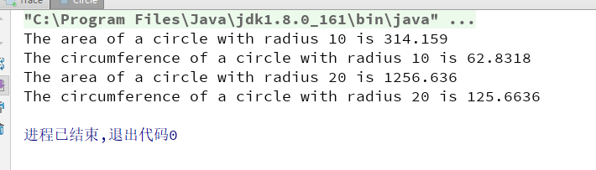
2. 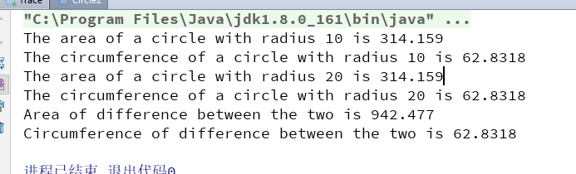
3. 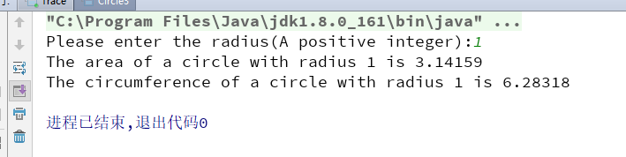

3) Answer questions

4)Error Analysis and Discussion

6 Painting a Room
1) Source code list

2) Results data processing

3) Answer questions

4)Error Analysis and Discussion

7 Ideal Weight
1) Source code list
package Chapter02;
import java.util.Scanner;
/**
* @Description:
* @Author: QiuGuanLin
* @Date: 2018/3/23 11:09
*/
public class IdealWeight {
public static void main(String args[]) {
String sex;
Scanner scan = new Scanner(System.in);
int ft, in;
double weight;
System.out.print("Please enter the sex : ");
sex = scan.nextLine();
System.out.print("Please enter the height(ft and in ex. 1 2) : ");
ft = scan.nextInt();
in = scan.nextInt();
if (sex.equals("男")) {
in = in + ft * 12;
weight = 106 + 6 * (in - 60);
} else {
in = in + ft * 12;
weight = 100 + 5 * (in - 60);
}
System.out.println("The best weight is :" + weight);
System.out.println("The health is :" + (weight - weight * 0.15) + " ~ "
+ (weight + weight * 0.15));
}
}

2) Results data processing
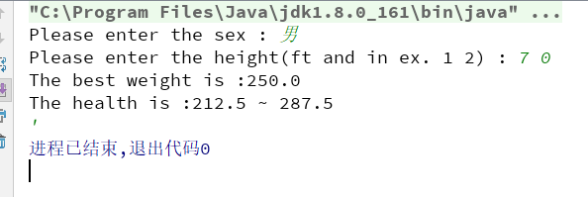

3) Answer questions

4)Error Analysis and Discussion

8 Lab Grades
1) Source code list
package chapter02;
import java.util.Scanner;
/**
* @Description:
* @Author: QiuGuanLin
* @Date: 2018/3/23 11:12
*/
public class LabGrade {
public static void main(String[] args) {
// Declare constants
final double IN_WEIGHT = 0.6; // in-class weight is 60%
final double OUT_WEIGHT = 0.4; // out-of-class weight is 40%
// Declare variables
int preLabPts;//number of points earned on the pre-lab assignment
int preLabMax;//maximum number of points possible for pre-lab
int labPts;//number of poitns earned on the lab
int labMax;//maximum number of points possible for lab
int postLabPts;//number of points earned on the post-lab assignment
int postLabMax;//maximum number of points possible for the post-lab
int outClassAvg; //average on the out of class (pre and post) work
int inClassAvg;//average on the in-class work
double labGrade; //final lab grade
Scanner scan = new Scanner(System.in);
// Get the input
System.out.println("\nWelcome to the Lab Grade Calculator\n");
System.out.print("Enter the number of points you earned on the pre-lab: ");
preLabPts = scan.nextInt();
System.out.print("What was the maximum number of points you could have earned? ");
preLabMax = scan.nextInt();
System.out.print("Enter the number of points you earned on the lab: ");
labPts = scan.nextInt();
System.out.print("What was the maximum number of points for the lab? ");
labMax = scan.nextInt();
System.out.print("Enter the number of points you earned on the post-lab: ");
postLabPts = scan.nextInt();
System.out.print("What was the maximum number of points for the post-lab? ");
postLabMax = scan.nextInt();
System.out.println();
// Calculate the average for the out of class work
outClassAvg = preLabPts + postLabPts / preLabMax + postLabMax * 100;
// Calculate the average for the in-class work
inClassAvg = labPts / labMax * 100;
// Calculate the weighted average taking 40% of the out-of-class average
// plus 60% of the in-class
labGrade = OUT_WEIGHT * outClassAvg + IN_WEIGHT * inClassAvg;
// Print the results
System.out.println("Your average on out-of-class work is " + outClassAvg + "%");
System.out.println("Your average on in-class work is " + inClassAvg + "%");
System.out.println("Your lab grade is " + labGrade + "%");
System.out.println();
}
}

2) Results data processing
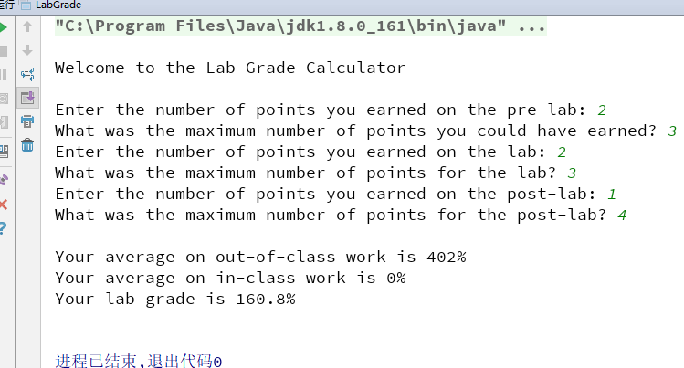

3) Answer questions

4)Error Analysis and Discussion

9 Base Conversion
1) Source code list

2) Results data processing

3) Answer questions

4)Error Analysis and Discussion

10 Introduction to HTML
1) Source code list

2) Results data processing

3) Answer questions

4)Error Analysis and Discussion

11 Drawing Shapes
1) Source code list
package chapter02;
/**
* @Description:
* @Author: QiuGuanLin
* @Date: 2018/3/23 11:19
*/
import javax.swing.JApplet;
import java.awt.*;
public class Shapes extends JApplet {
@Override
public void paint(Graphics page) {
// Declare size constants
final int MAX_SIZE = 300;
final int PAGE_WIDTH = 600;
final int PAGE_HEIGHT = 400;
// Declare variables
int x, y;// x and y coordinates of upper left-corner of each shape
int width, height; // width and height of each shape
// Set the background color
setBackground(Color.yellow);
// Set the color for the next shape to be drawn
page.setColor(Color.blue);
// Assign the corner point and width and height
x = 200;
y = 150;
width = 100;
height = 70;
// Draw the rectangle
page.fillRect(x, y, width, height);
}
}

2) Results data processing
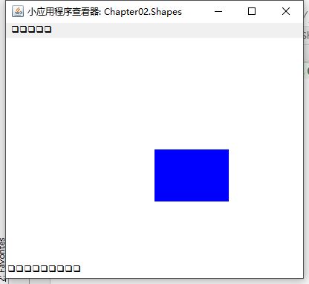

3) Answer questions

4)Error Analysis and Discussion

1 Names and Places
1) Source code list

2) Results data processing

3) Answer questions

4)Error Analysis and Discussion

